

**YEAR: 10**

**SUBJECT: Science**

**ANSWERS**

**Space**

**ATAR Pathway**

**Please do not mark this paper.**

1. The most widely accepted theory that explains where our universe came from is
2. Steady State theory.
3. The Atomic theory.
4. The Big Bang theory.
5. The Global theory.
6. Hubble observed that galaxies are
7. Moving toward us.
8. Moving away from us.
9. Expanding.
10. Standing still.
11. What is Cosmic Microwave Background (CMB) Radiation?
12. The first primordial elements.
13. Red shifted galaxies.
14. Leftover heat from the Big Bang.
15. The shape of the universe.
16. What was the force that allowed galaxies to form in the early universe?
    1. Gravity
    2. Background radiation
    3. Anti-matter collisions
    4. Weak nuclear force
17. Which of the following is not a dwarf star
18. White
19. Brown
20. Black
21. Grey
22. What is the shape of the Milky Way
23. Spiral
24. Irregular
25. Elliptical
26. Oval
27. Use the diagram below to identify all the stars you would be able to see in July.

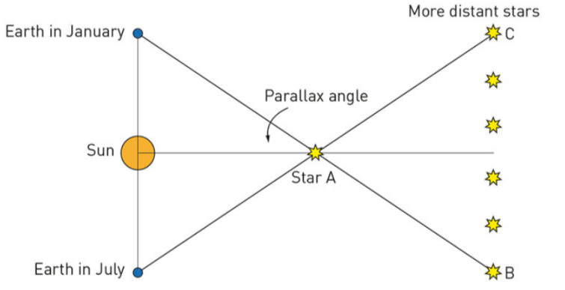

B

C

D

E

F

G

1. A, B, C, D, E, F, G
2. A, D, E, F
3. A, B, G
4. A, C, D, E, F, G
5. Read the table below regarding Galaxy A’s movement in space. Choose the option that correctly explains red shift and blue shift in relation to the Doppler effect.

|  |  |  |
| --- | --- | --- |
|  | Galaxy A | Doppler effect |
| a) | Blue shift - moving away | Frequency increase |
| b) | Red shift - moving toward | Frequency increase |
| c) | Red shift - moving away | Frequency decreases |
| d) | Blue shift - moving toward | Frequency decreases |

1. Which one represents the most correct definition for a lightyear?
2. The time it takes light to travel 1 year
3. The distance travelled by light in 1 year
4. The amount of light seen in 1 year
5. The amount of light a black hole absorbs in 1 year
6. What is the correct order from smallest to largest of the following objects found in space?
7. Red giant, galaxy, main sequence star, planet, universe
8. Universe, galaxy, red giant, main sequence star, planet
9. Planet, main sequence star, red giant, galaxy, universe
10. Planet, red giant, main sequence star, universe, galaxy



**Space Test   
ATAR Pathway**

**ANSWER BOOKLET**

**NAME:**

**FORM: DATE:**

**ASSESSMENT KEY**

|  |  |
| --- | --- |
| **I CAN STATEMENTS** | **QUESTIONS** |
| **MUST**  **Describes the evidence for the Big Bang theory.** | 1, 2, 3, 5, 6, 7, 9, 10, 11, 13, 14, 16, 17, 18 |
| **SHOULD**  **Explains the evidence for the Big Bang theory.** | 4, 12, 13, 14, 17, 18 |
| **COULD**  **Explains and evaluates the evidence for the Big Bang theory.** | 8, 13, 15 |

**Multiple Choice Short Answer Extended Answer Total**

**/40**

**/47**

**/8**

**/5**

**/22**

**/32**

**/10**

**/10**

**SECTION ONE: Multiple choice answers**

**Cross (X) through the correct answer.**

|  |  |  |  |  |
| --- | --- | --- | --- | --- |
| **1** | **a** | **b** | **XXX** | **d** |
| **2** | **a** | **XXX** | **c** | **d** |
| **3** | **a** | **b** | **XXX** | **d** |
| **4** | **XXX** | **b** | **c** | **d** |
| **5** | **a** | **b** | **c** | **XXX** |
| **6** | **XXX** | **b** | **c** | **d** |
| **7** | **a** | **b** | **c** | **XXX** |
| **8** | **a** | **b** | **XXX** | **d** |
| **9** | **a** | **XXX** | **c** | **d** |
| **10** | **a** | **b** | **XXX** | **d** |

**SECTION 2: Short Answer**

Question 11 (2 marks)

Define the following terms:

* 1. Galaxy

**COLLECTION/GROUP OF (1/2) DUST, GAS AND STARS (1/2)**

* 1. Star

**BALL OF BURNING HYDROGEN (1/2) AND HELIUM (1/2) GAS**

Question 12 (1 mark)

Identify the reaction that takes place in a star.

**NUCLEAR FUSION**

Question 13 (4 marks)

Star A is 4 light years from earth and B is 56 light years from Earth. Star A is a red giant, Star B is in the supernova stage.

Describe the brightness of the two stars in relation to the two brightness scales.

*ABSOLUTE MAGNITUDE – THE ACTUAL BRIGHTNESS OF A STAR*

*APPARENT MAGNITUDE – THE BRIGHTNESS OF A STAR VIEWED FROM EARTH*

**SUPERNOVA WILL BE BRIGHTER (1) USING THE ABSOLUTE MAGNITUDE SCALE (1)**

**RED GIANT WILL APPEAR BRIGHTER BECAUSE IT IS MUCH CLOSER (1) BECAUSE OF APPARENT MAGNITUDE (1**

Question 14 (6 marks)

Place the following words in the boxes below to show the lifecycle of a star.

Red giant White dwarf Stellar nebula Planetary nebula Main Sequence

Super giant Black dwarf Supernova Protostar Black hole Neutron Star

Stellar nebula

Protostar

Main Sequence

Red giant Supergiant

Planetary nebula Supernova

White Dwarf Black hole Neutron Star

Black Dwarf

½ mark for each correct answer

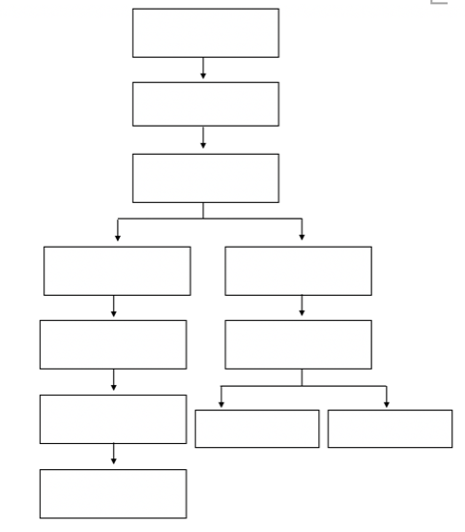

What does the path of the star depend on? **MASS** ½ mark

Question 15 (4 marks)

Compare and contrast the three types of galaxies.

1 mark for listing all 3 galaxy types, no ½ marks because in MC

1 mark per statement for specific detailed statement of similarity or difference

|  |  |  |
| --- | --- | --- |
| **Spiral galaxies** | **Elliptical galaxies** | **Irregular galaxies** |
| Top and side views of spiral galaxies | An elliptical galaxy | An irregular galaxy |
| Huge; contain stars, gas, and dust | Huge; contain stars, gas, and dust | Huge; contain stars, gas, and dust |
| Held together by gravity | Held together by gravity | Held together by gravity |
| Pinwheel shape (see top view of Spiral 1, above) | Round-to-oval shape | No regular shape |
| Bulge and thin disk; halo is present (see side view of Spiral 2, above) | Bulge but no disk; halo is present | May show signs of a disk and/or a bulge; halo is present |
| Rich in gas and dust | Little cool gas and dust | Usually rich in gas and dust |
| Young and old stars are present | Mainly old stars are present | Young and old stars are present |

Question 16 (2 marks)

What were the two positions of the emu in the night sky calendar and what did they represent.

**SITTING (NO LEGS) / IMAGE OF AN EGG (1/2) – TIME TO COLLECT EGGS(1/2)**

**RUNNING EMU(1/2) – TIME TO HUNT EMUS / EMU FINDING A MATE (1/2)**

Question 17

Use the diagram below to answer the following questions (3 marks)

**A**

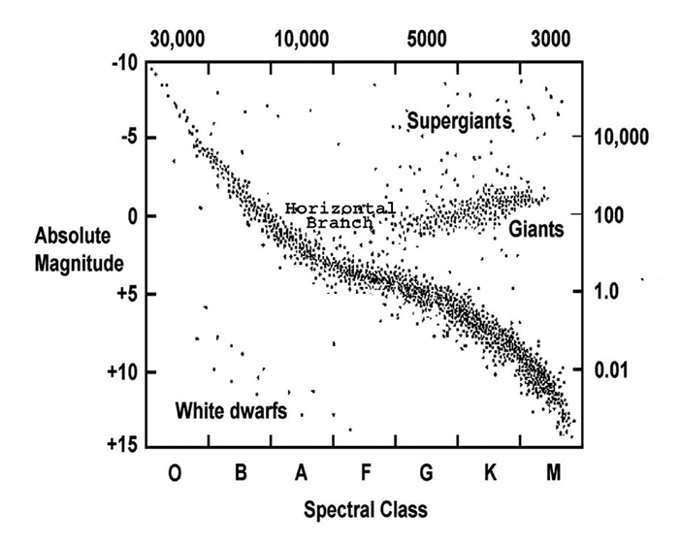

**B**

Identify what the following letters represent

A**TEMPERATURE (1)**

B**MAIN SEQUENCE (1)**

Which properties change as a star becomes a white dwarf

**HIGH TEMPERATURE (1/2) DROPS SIZE (1/2) GETS DIMMER (1/2) CHANGE COLOUR/SPECTRAL CLASS (1/2)**

**MAX 1 MARK**

**SECTION 3: Extended Answer**

Question 18 (8 marks)

Explain why the Big Bang is only a theory and identify two pieces of evidence that support it. Define and link the piece of evidence to the theory of the Big Bang using a diagram.

* EXPLANATION OF ORIGIN OF UNIVERSE **BASED ON EVIDENCE NOT PROOF. (1)**
* **RED SHIFT (1) – UNIVERSE IS EXPANDING AND MOVING AWAY FROM EACH OTHER (1) SINCE THE BIG BANG (1)**
* **COSMIC MICROWAVE BACKGROUND RADIATION (1) – BACKGROUND RADIATION IN SPACE (1) THAT IS THE OVER FROM THE BIG BANG (1)**

Diagram:

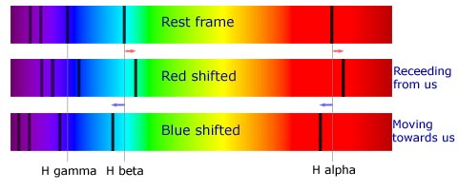

**End of test. Please edit your work prior to submission.**